Reaction Rates and Le Chatelier’s Principle
Reaction rate: The rate at which reactants are consumed to create products ie. how fast successful collision occur.
~Collision theory; For a successful reaction to occur, reacting particles must:
- Collide;
- With sufficient energy ie. equal or exceed activation energy (E_{a})
- With the correct orientation
~Ways to increase reaction rate (increase total collisions, or increase success rate of collisions)
~Temperature: Increases average kinetic energy, giving more energy for particles to collide with. This has two effects:
- Increases total collisions (particles move faster hence more collisions)
- Gives a higher %age of particles sufficient energy to collide (success rate of collisions increases)
~Concentration: Increases number of reactants initially available.
~Increases total collisions (more particles to collide with thus increases total number of collisions)
~Volume/Pressure: Decreases the volume in which gaseous particles occupy
~Increases total collisions (less room for gaseous particles to occupy bring the gaseous molecules closer; increasing total number of collisions)
~State of sub-division/surface area: Increases the amount of readily available reactants
~Increases total collisions (more readily available reactants from the beginning increases the number of molecules readily available thus increases total collisions)
~Catalyst: A species which is not a reactant or product; solely introduced to increase reactions rate
~Lowers required activation energy for successful collision (increasing %age of successful collisions thus increasing reaction rate)
~Corrects orientation of reacting particles (increasing %age of successful collisions thus increasing reaction rate)

Le Chatelier’s principle: To predict shifts in equilibrium after alterations
~Dynamic equilibrium: When the forward rate of reaction = reverse rate of reaction. Can be only achieved in a closed system and when the reaction is reversible. Seen when physical properties e.g. colour, pressure are constant.
~Equilibrium constant; numerical value determining the favouring of forward/reverse reactions
~When aA + bB >< cC +dD K_{C} = ([A]ª x [B]^{b}) / ([C]^{c} x [D]^{d})
~Only use particles with an concentration (aqueous solutions or gaseous species). Liquids and solids do not have varying concentrations hence given the value
~Large K_{C} implies favouring forward reactions while small K_{c} implies favouring reverse reaction. K_{C} ≈ 1 significant concentrations at equilibrium
~Reaction Quotient expression (Q_{c}) has the same formula but the term “Q_{c} is used when system is not at equilibrium. When Q_{c} = K_{c}, system is at equilibrium
` ~Changes to dynamic equilibrium
~Concentration
~Increase in concentration favours the reaction using it up (we have extra? Get rid of it)
~Decrease in concentration favours the reaction creating it (we have too little? We need more)
~Addition of liquids or gases do not alter equilibrium constants
~Except for water; which drops the concentrations of all species with concentrations
~Total Pressure
~Increase in pressure/decrease in volume favours reaction with less gaseous moles (too crowded, need less gas)
~Decrease in pressure/increase in volume favours reaction creating more gaseous moles (too spacious, need more gas

~Temperature
~Increase in temperature favours the endothermic reaction (too hot, need to absorb heat)
~Decrease in temperature favours the exothermic reaction (too cold, need to create heat)
~Also is the only variable that changes K_{C}
~How to answer Equilibrium questions? Based off Collision Theory
- Reaction rate: How is reaction rate affected? What is the final outcome?
- Acknowledge the equation: How will Le Chatelier’s predict? Using the equation, why does Le Chatelier’s come to that conclusion?
- Which reaction is favoured? “Favouring” comes through the increase (or decrease) of reaction rate of a certain reaction
- Final Statement: “A greater proportion of (reactants/products) due the forward/reverse reaction being favoured.”

Energy profile diagrams
Activated Complex/ Transition state
Highly unstable with the most potential energy: all bonds broken, no bonds formed

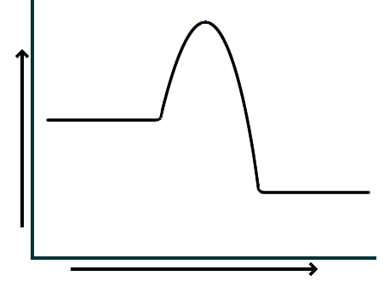

Activation Energy (E_{a})
The required energy needed in order for the reaction to occur
Enthalpy: A measure of energy including both potential and kinetic energy.
Reactants
ΔH
Products
Change in Enthalpy/Heat of reaction
Net energy change;
+ve ΔH suggest endothermic reaction
-ve ΔH suggests exothermic reaction

Progress of Reaction
(What happens if it was backwards. What will the changes to E_{a}, ΔH and the overall shape be?

Ocean Acidification: Increasing H⁺(aq) in ocean ie decrease of pH.
~Full equations for ocean equilibrium
1. CO₂(g) >< CO₂(l)
2. CO₂(aq) + H₂O(l) >< H₂CO₃(aq)
“Ocean’s buffering system” through Le Chatelier’s Principle
3. H₂CO₃(aq) >< H⁺(aq) + HCO₃⁻(aq)
4. HCO₃⁻(aq) >< H⁺(aq) + CO₃²⁻(aq)
~Effects include; coral bleaching, weakening shells (reducing CO₃²⁻ for CaCO₃ shells)

Acid and bases
Arrhenius Theory
~Acids will ionize in solution producing H⁺ ions
~Bases will dissociate in solution releasing OH⁻ ions
~Strong acids and bases ionize/disassociate fully, indicated with a single, forward arrow. Weak acids and bases will only partially ionize/disassociate, indicated by a double forward and reverse arrow
~Limitations: Only applied behaviour in aqueous solutions, only predicts bases with hydroxides e.g. carbonates, oxides and salts are all basic, but are not predicted since they will not release H⁺ or OH⁻
Bronsted-Lowry Theory
~An acid will donate a proton ie. H⁺ donors. When ionised in water (hydrolysis), creates H₃0⁺
~A base will accept a proton ie. H⁺ acceptors. When undergoes hydrolysis, creates OH⁻
~When reversible, there are “conjugate acids” (from forward base) and “conjugate bases” (from forward acid); showing that both forward and reverse are acid-base reactions. Difference between pairs should be by a H⁺
K_{a}/ Acid dissociation constant; numerical value of the extent to which proton transfer reaction goes to completions ie. Acid strength indicator.
~K_{a}= [forward product] x [forward product] … / [forward reactant] x [forward reactant] …
~Only include species with a concentration ie. Gaseous and aqueous (solids and liquids have constant concentration thus is only “1.”
~If K_{a} is large, favour forward reaction ie acid is strong and conj. Base is very weak.
~If K_{a} becomes smaller, more favouritism to reverse reaction ie. Conj. Base becomes a stronger base
Polyprotic acids; acids which are willing to donate 2 or more protons per molecule (H⁺)
`~The more protons donated, the less acidic it is (less willing to donate a proton) thus the Ka decreases
~e.g. H₂SO4(aq) > HSO₄⁻(aq) + H⁺(aq) >SO₄²⁻(aq) + H⁺(aq)

Acidity of a salt
Acidic Neutral
Basic
Cations
Na⁺ | K⁺ | Rb⁺ | Cs⁺
Mg²⁺ | Ca²⁺ | Sr²⁺ | Ba²⁺
Anions
Cl⁻ | Br⁻ | I⁻,
ClO₄⁻ | BrO₄⁻ | ClO₃⁻ | NO₃⁻

NH₄⁺ | Al³⁺ | Pb²⁺ | Sn²⁺
Transition metal ions
HSO₄⁻ | H₂PO₄⁻
F⁻ | C₂H₃O₂⁻ | NO₂⁻ | HCO₃⁻
CN⁻ | CO₃²⁻ | S²⁻ | SO₄²⁻
HPO₄²⁻ | PO₄³⁻

Acidity and pH
~ H₂0 >< H⁺ + OH⁻ ΔH=55.8 kJ/mol
~K_{w} (autoionisation of water) = 1 x 10⁻¹⁴ (at 25°C) meaning [H⁺][OH⁻]=1 x 10⁻¹⁴
~ ie. K_{w} suggests very small tendency for water to ionise, but K_{w} changes with temperature ie. Higher temp >> higher K_{w}
~pH = -log([H⁺]) /// 10^{-(pH)} = [H⁺]
~Lower pH =more acidic, less basic /// higher pH =more basic, less acidic /// pH= 7 = neutral

Buffers; weak acid/conjugate base or weak base/ conjugate acid pairs which work to resist pH change. Works through Le Chatelier’s principle
~Buffer Capacity; the strength of the buffering power of a buffer ie. Ability to neutralise excess acid or base without an appreciative change in pH.
~High concentration of both acid/base conjugate pairs (so both species do not get depleted or reduced in conc.
~Similar concentrations of acid/base conjugate pairs
Ie. pKa = [forward conjugate pair] / [forward acid/base] ≈ 1
~Ionisation constant; [H⁺]/[HA]

Titration; Goal; to find the equivalence point, thus finding an unknown solution’s concentration
~Equivalence point; the theoretical point in which neither acid nor base remains ie. Point of neutralisation. Depending on the combo of strength of acid and base, this may happen and varying pH’s
~End point; the practical point in which equivalence point is observed/estimated. Through a suitable pH indicator, the colour of the aliquot will change when a certain pH is reached, thus suggesting end point has been reached. End point is an estimate of the equivalence point
~Aliquot; sample of the acid/base solution
~Titre; solution added to aliquot from the burette
~Acid-Base indicator; a weak acid or base which changes colour based on the acidic/basic form it takes. They can change colour based on pH because they change forms at varying pH’s
~Hind + H₂0 >< H₃0⁺ + Ind⁻ << acidic hydrolysis of indicator (Le Chats anyone?)
~Standard solution; one solution with known concentration
~Primary standards must;
~Have high molar mass
~Stable ie. Not readily react in air
~Found in a pure form which is consistent with chemical formula
~Secondary standards; a solution which concentration is found during the titration ie. Back titrations

~Errors; mistakes made affecting the results of the titration
~Accuracy; how close it is to the true value
~Precision; set of measurements which are in an acceptable range of true value
~Random error; the cause of inconsistent results; e.g. rinsing poorly, careless attention to end point change, poor technique. Cannot be eliminated by can be reduced through repetition ie. Repeating titration
~Systematic error; the cause of consistently lower or consistently higher results; e.g. choosing the wrong indicator. Eliminated by using correct technique.
~Examples of errors
~Clean; firstly with detergent to stop water sticking on glassware
~Final rinse; pipette, burette and storage bottle with reagent to be filled with; Flasks are cleaned with distilled water
~Choosing indicator; Use only a few drops (consistently) Choose with distinct colour change which change comes close to the pH of equivalence point
~ low pH (strong acid, weak base)
>> methyl orange (red <3.1 // yellow >4.4)
~ neutral pH (same strength)
>> bromothymol blue (yellow <6 // blue >7.6)
~ high pH (weak acid, strong base)
>> phenolphthalein (colourless <8.3 // pink >10)
~Reading scales; read at horizonal eye level
~Discharge pipette; allow time for liquid to drain
~End point; drop titre dropwise while swirling. Watch carefully for end point
without overshooting.
~Titration curve; curve how pH in conical flask changes rapidly at equivalence
~Inflection in graph represents equivalence point
~Check where inflection occurs ie. At what pH and compare with colour change of chosen indicator for suitability
~Complete neutralisation≠pH=7
~Neutralisation between strong base + weak acid or vice versa…

Redox: A type of reaction where a species gets oxidised and another reduced
~Oxidised; the loss of one or more electrons
~Reduction; the gain of one or more electrons

~Common redox reactions
~Metal-metal ion: Oxidation of metal element, reduction of aqueous metal less reactive to previous metal element ie. Electrons go from metal element to aqueous metal
~Halogen-halide ion displacement: Oxidation of less reactive halide, reduction of a halogen ie. Electrons go from halide ion to halogen
~Combustion (BURNNN!!!!): Oxidation of fuel, reduction of O₂(g)
~Corrosion of iron: Oxidation of reactive metal, reduction of O₂ (g)
~Oxidation numbers
~How to determine Oxidation numbers
~Free state e.g. Cl₂(g) = 0
~Monoatomic have oxidation no. equal to charge e.g. Al³⁺⁽aq) = 3
~Hydrogen atoms bonded have +1 e.g. H, in HCl = 1
~Hydrides e.g. H in NaH has -1
~Oxygen atoms bonded have -2 e.g. O, in H₂O = -2
~Peroxides ie. O in H₂O₂, have -1
~If there are a change in oxidation numbers from reactants to products, then it is a redox reaction
~Increase in oxidation number = species being oxidised ie. Reducing agent
~Decrease in oxidation number = species being reduced ie. Oxidising agent
~Confused? Remember “agent” = a trigger for something to happen therefore the “______ agent” is the thing that makes ______ happen

~Half Equations; half equations of a redox reactions
- Show both the species and the product of half equation
- Balance element
- Balance O by adding H₂O if needed
- Balance H by adding H⁺ if H₂O was needed
- Balance CHARGE by adding e-

Table of Standard Reduction Potentials: Table ranking the strength of oxidising agents (reduced species)
~” Standard”: at SLC, 1 mol. Relative to the reduction by H₂ gas (that’s why you have “exactly 0”)
~” Reduction”: Comparing reduction reactions ie. The further up, the more likely to be reduced the further down, the more likely to be oxidised
~” Potentials”: The voltage theoretically created (E₀)
~If E₀ > 0, reaction will be spontaneous
Electrochemistry
Galvanic Cell
Galvanic/ Electrochemical/ Voltaic cells
~To create electrical energy by using chemical energy
~This is done through voltages from spontaneous redox equations
Salt bridge: allows ions to pass between oxidising and reducing agents without direct contact
Cations to cathode Anions to anode
Electrons flow from – to +
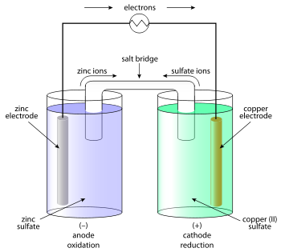

Zinc Cathode will lose mass, since product is Zn²⁺(aq)

Copper Cathode will gain mass, since product is Cu(s)
OILRIG, AN OX//RED CAT?

Electrolytic Cell
External power supply provides energy for a normally non-spontaneous redox to occur
Inert (non-reactive) electrodes; do not get involved in the chemical reaction. When voltage is added, the electrodes become oppositely charged
Electrolytic/ Electrolysis cell
~To create chemical change by using electrical energy
~This is done by using an external electrical power supply to power what would’ve been a non-spontaneous reaction

Same; remember- oxidation is loss of electrons, reduction is the gain of electrons (AN OX and RED CAT still apply)
~Cations to Anode, Anions to Cathode
~Electrons from + to –
~Electrolytic: “don’t PANIC”
(Positive Anode Negative in Cathode)

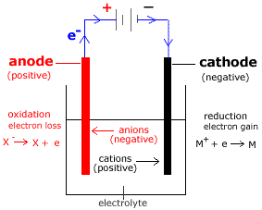

Electrolyte: solution that readily disassociates. Provides the ions which them move to respective electrodes

~Possible to get reactive electrodes or aqueous salts
~Reactive electrodes e.g. Cu(s) electrodes will have one electrode lose mass (anode) and the other gain mass (cathode)
~If water is oxidised, O₂(g) forms at anode, what happens to pH?
2H₂O(l) >> O₂(g) + 4H⁺ (aq) + 4e⁻
~If water is reduced, H2(g) forms at cathode, what happens to pH?
2H₂O(l) + 2e⁻ >> H₂(g) +2OH⁻(aq)

Types of Galvanic cells
~Primary cell; non-rechargeable cells (single use) because amount of oxidant and reductant is fixed thus cannot be added to “recharge”. Examples include; dry cell, alkaline cells, silver oxide button cell, lithium cell.
~Secondary cell; rechargeable cells (multi use). Recharged by adding a voltage (electrolysis) to reverse the spontaneous, discharge reaction, to regenerate original oxidant and reductant by reversing anode and cathode half reactions.
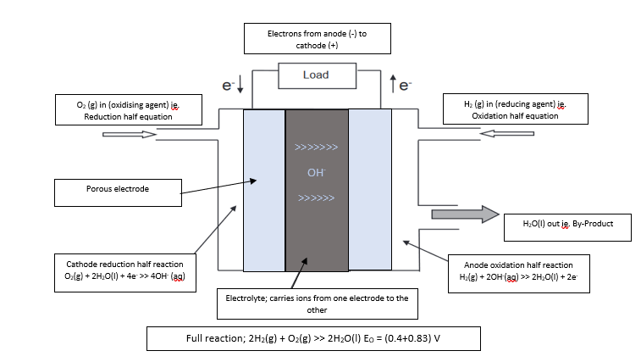
~Fuel cells; not primary or secondary. Generates electricity through the constant addition of oxidising and reducing agents ie. Does not store contents.

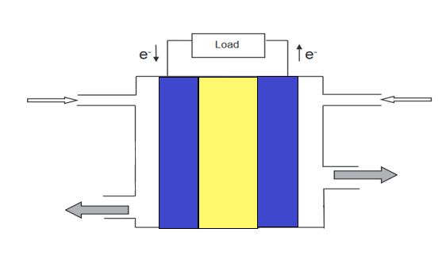
H₂(g) in
O₂(g) in

>>>>>>
H+
>>>>>>

Depleted fuel and gases out
Remaining O₂(g), heat, H₂O(l) out
Electrorefining and Electroplating
~Electrorefining: To remove impurities from blister (impure) copper through electrolysis
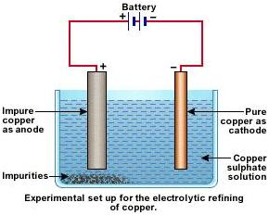

Pure Copper as cathode; gains mass from copper from blister cathode. Only gains copper because lower reduction potential of impurities.
“Anode Slime”: Less reactive metals ie. More likely to reduce, do not dissolve due to lower oxidation potentials
Impure Copper as anode; will lose mass ie. impurities become part of “anode slime. Copper will oxidise and solidify at cathode.
C
Electrolyte made up of based on cation ie. Copper coating ie. Copper Sulfate
Impurities which are more likely to oxidise will also oxidise from blister copper but, will not form solid at pure copper.

~Electroplating: To add a thin coating of a metal onto another metal
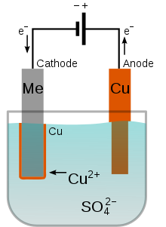
Cathode: Metal to be coated
Why? Because CATHODE GAINS MASS (from anode)
Anode: Metal to make up the coating
Why? Because ANODE LOSES MASS (to go to cathode)

Electrolyte made up of based on cation ie. Copper coating ie. Copper Sulfate

Organic Chemistry
~Alkanes; straight chains with single bonds
~Strongest intermolecular force is dispersion force ie. Small amount of energy required to break intermolecular bonds
~Undergo substitution (CH₄ +Cl₂ >> CH₃Cl + HCl) ie. Replacing a H with a halogen and form another small molecule
~Combustion
~Alkenes; straight chains with double bonds
~Strongest intermolecular force is dispersion force ie. Small amount of energy required to break intermolecular bonds
~Undergo Addition reaction (CH₂CH₂ + Br₂ >> (Br)CH₂CH₂(Br) ie. Breaking the double bond
~Combustion
~Hydration e.g. CH₂CH₂ +H₂O >> CH₃CH₂OH ie. Making an alcohol
~Markovnikov’s rule; H goes to the C with most H’s, other goes to the C with less H’s
~Alcohols; Has an -OH group (hydroxyl group), named with a “-ol”
~Strongest intermolecular force is hydrogen bonds ie. Large amounts of energy required to break intermolecular bonds
~Primary alcohols (C connected to OH has only another C connected to it) oxidise to aldehydes (incomplete) and then to carboxylic acids (complete)
~Secondary alcohols (C connected to OH is connected to two other C’s) oxidise to ketones
~Tertiary alcohols (C connected to OH is connected to three other C’s) do not oxidise
~Aldehydes; Has an -CHO group; named with a “-al”
~Strongest intermolecular force is dipole-dipole ie. Moderate amounts of energy required to break intermolecular bonds
~Ketones; Has a -C=O (carbonyl) group; named with a “one”
~Strongest intermolecular force is dipole-dipole ie. Moderate amounts of energy required to break intermolecular bonds
~Carboxylic acid; Has a -COOH (carboxyl group = carbonyl + hydroxyl); named with -oic acid
~Strongest intermolecular force is hydrogen bonds ie. Large amounts of energy required to break intermolecular bonds. Also has the double bond O suggesting more energy is required to break intermolecular bonds compared to alcohol, even though both exhibit H-bonding (strongest intermolecular force)
~This and alcohol needed for esterification
~Weak acids which can also undergo hydrolysis
~CH₃COOH(aq) + H₂O(l) >< CH₃CHOO⁻(aq) + H₃O⁺ (aq) K_{a}=1.75 x 10⁻⁵
~Amine; has a -NH₂ (amine or amino) group; named with -amine
~ Strongest intermolecular force is dipole-dipole ie. Moderate amounts of energy required to break intermolecular bonds
~Amides; has a -CONH₂ group (carbonyl + amine); named with -amide
~ Strongest intermolecular force is dipole-dipole ie. Moderate amounts of energy required to break intermolecular bonds. Also has the double bond O suggesting more energy required to break amide intermolecular compared to amine intermolecular.

~Esters; product of the reaction between an alcohol and carboxylic acid in acidic condition
~R₁-COOH + HO-CH₂-R₂ >< R₁-COO-CH₂-R₂
~Generally have a fruity smell
~Can undergo hydrolysis
~In acidic conditions, creates carboxylic acid and alcohol (ie. The reactants)
~In basic conditions, creates carboxylate salt and alcohol (don’t forget the signage of the salt!)
~Physical properties of organic compounds
~Solubility in water; how well it dissolves in water (polar solution)
~Shorter chains, polarity within molecule and stronger intermolecular forces result in high solubility
~Boiling point/melting point; how much energy is needed to break bonds
` ~Longer chains, polarity within molecule and stronger intermolecular forces result in higher BP/MP

Saponification: Making a soap from animal fat or vegetable oil.
CH₂-O-C(O)-(CH₂)₁₆-CH₃ *3 +3NaOH > CH₂-OH *3 + 3Na-O-C(O)-(CH₂)₁₆ CH₃
(Ester + strong base >> Soap with Carboxylic bit + Alcohol)
Detergents are (R-Benzene ring-(2
9 8O⁻Na⁺) where R= aliphatic chain with +10 carbons
Cleaning action; Hydrophobic tail dissolve in grease (dispersion) and hydrophilic head is intermolecularly bonded to the water (dipole/hydrogen bonding). Through agitation, dirt is lifted off fabric using the cleaning agent as a medium.
Hard water: Water with high conc. of Ca²⁺ and/or Mg²⁺ ions.
Soaps don’t work in hard water because they form insoluble substances with Ca²⁺ and Mg2+. Detergents work in hard water and you need less detergent to clean the same stain as soap but detergents come from synthetic material e.g. H₂SO₄ and petroleum products.
Macromolecules: extremely large molecules like synthetic mers (e.g. polypeptides, proteins like DNA, RNA and polysaccharides like cotton).

Polymers/Plastics/Synthetics:
~Can be made into fibres for fabric e.g. nylon, polyester, polypropene, Teflon, Kevlar
~Thermoplastics: soften when heated, therefore can be melted and reshaped e.g. PET, HDPE, PVC
~Thermosetting: char or decompose to original monomer when heated ie. Cannot be reshaped by heating
Polymerisation: Joining monomers together to create a polymer
~Cross linking: chains joined to other chains.
~Addition Polymerisation: saturation of double bond through polymerization.
~Condensation Polymerisation: Polymerisation which results in the loss of small molecules ie. H₂0 or CO₂

Polypeptides: Natural polymers formed by the combination of alpha amino acids.
~Alpha amino acids; NH₂ group is connected to the same C which is connected to the COOH group ie.
R-CH₂(NH₂)-COOH where R is the rest of the chain
~Zwitterions; an ion with a positive and negative charge but is a neutrally charged ion overall.
~Created by removing a H where possible (generally from COOH groups) and adding it wherever possible (generally to a NH₂ group)
Protein: 50+ chain of alpha amino acids ie. Long polypeptide.
~Primary structure: linear sequence of peptide chain
~ Primary structure sequence starts at N-Terminus (The NH₂ end) while the primary structure sequence finishes at the C-Terminus (COOH end). Therefore, all proteins have NH₂ and COOH
~Secondary structure: regular arrangement of the sections of the protein chain.
-Alpha Helix: A coiled ribbon formed through the H-bonds between the protein backbone and N-H / C=O bonds. N is 4 residues away from each other.
-Beta Pleated Sheets: Flat sheets held together by the H-bonds between different parts of the one polypeptide chain or between different polypeptide chains.
~Tertiary Structure: Overall 3D shape caused by ionic and disulfide bridges, dispersion force and H-bonds to adjacent chains. Disulfides are strong due to oxidation; stronger than H-bonds. Ionic bonds are very strong.
Enzymes: Proteins with a specific shape and complex structure which act as catalyst for specific reactions (enzyme specificity)
~Lock and Key model: How Enzymes catalyse reactions which break apart the substrate molecule.
- Substrate approaches enzymes active site
- Intermolecular forces hold substrate down. Substrate begins to change through the breaking and forming of new bonds; ie. New substances are being created
- Changed substrate releases from active site as substrate is not being held by intermolecular forces anymore.
~Benefits of using enzymes;
-less chance of side reactions and creation of unwanted by products
~speeds up reactions for economical production which usually would need high temp/pressure for the same rate
~Disadvantages of using enzymes
-needs to work under specific temperature and pH conditions.
-increasing concentration of substrate does not increase reaction rate (must wait for the previous substrate to finish catalysing first.

Chemical Synthesis: “Creating chemicals”
Goal: maximise yield and rate of production
Green Chemistry: Clean Chemistry
- Prevent chemical waste is better than treating it
- Incorporate all materials in the process
- Reduce hazards
- Minimize toxicity of chemicals
- Use safe chemicals whenever can
- Be energy efficient
- Use renewable, raw materials when can
- Use less derivative reactions
- Use catalysts because they’re better than reagents
- Design for self-degrading products that will not stay in environment for too long
- Analyse in real time
- Accident prevention is good
Factors resulting in a reduced yield of products
Loss of reagent due to side reactions
Physical loss of products ie. Cannot fully separate products
Incomplete equilibrium reactions
Presence of impurities in reagents ie. Reagent added is not the same as amount measured
Why do we use catalysts?
~Increase rate of formation of products
~Better yield at lower temperatures therefore catalysts make rate viable
~Some are reusable ie. Cost effective
~Lowers operating temperature and pressure
~Saving fuel
~Making it safer
~Reducing thermal pollution

Biofuels: Creating fuel from biomass
Advantages
Biofuels are renewable resource while fossil fuels aren’t
Biofuels have limited to no health consequences
Balances out in the carbon cycle (photosynthesis just creating mass again)
Petroleum fuels create SO₂ which is dangerous for people inhaling
Biofuels burn cleaner
Not much energy needed to create fuel
Disadvantages
More workers are needed
Slow process
Needs to distill to be made pure

Ethanol creation through Fermentation
Hydrolysis: from sucrose to glucose/fructose
Fermentation: from glucose/fructose to ethanol
Ie. C₆H₁₂O₆ + H₂O >> 2C₂H₅OH + 2CO₂
Fractional distillation: To obtain pure ethanol
Ethanol creation through synthesis of ethene
Hydrolysis with steam: From ethene to ethanol ΔH = -45kJ/mol
Fractional distillation: To obtain pure ethanol

Biodiesel: Methyl or Ethyl esters created by the (strong) base catalysed trans-esterification of triglycerides.
- Remove water- don’t want triglyceride turning into soap
- FFA (Free fatty acid) content below 4%
- Treat with methanol or ethanol to create ester
- Washed and dried
Petroleum biodiesel looks like; H₃C-(CH₂)₁₄-CH₃
Biodiesel will look like; H₃C-O-C(O)-(CH₂)₁₃-CH₃
Advantages of using lipase (enzyme) as a catalyst instead of NaOH or KOH
Milder pH and temperature range
Simultaneously catalyse transesterification of TG and esterification of FFA into biodiesel
Less energy needed in the whole reaction
Simplify purification process and reduce environmental problem
No side reactions if done correctly
Disadvantages of using lipase as a catalyst
Slower acting than strong base
Expensive compared to strong base
Hard to recover lipase after it’s used as a catalyst
Haber process: create NH₃
N₂ (g)+ 3H₂ (g)> 2NH₃ (g) ΔH=-92 kJ/mol
Compressor: maintains 15000-35000 kPa. Forces particles to enter converter
Convertor: maintains 350-550°C. Converts the N₂(g) and H₂ (g) into NH₃ (g)
Condenser: Cools the NH₃ gas into liquid form to separate from the N₂ and H₂. NH₃ gets stored while remaining H₂ and N₂ go back into the convertor.

Contact process: create H₂SO₄
- S(l) + O₂(g) > SO₂(g) ΔH=-297kJ/mol
Molten sulfur is burnt ion dry air around 1000°C
- 2SO₂(g) + O₂ (g) <> 2SO₃(g) ΔH = -198 kJ/mol
Sulfur dioxide is converted to sulfur trioxide

  - SO₃ (g) + H₂SO₄(l) >H₂S₂O₇(l)
  - H₂S₂O₇(l) + H₂O(l) > 2H₂SO₄(l)
  - SO₃(g) + H₂O (l) > H₂SO₄
Going through the creation of Oleum (3a) adding water to Oleum (3b) creates H₂SO₄.
3c is the full equation
(If it is just H₂O + SO₃, we would only get mist particles of H₂SO₄.

Manufacture of ethyl ethanoate
Ester reaction of CH₃CH₂OH and CH₃COOH
Can you go from CH₂CH₂ to CH₃COOCH₂CH₃?
Uses extra of the CH₃CH₂OH because CH₃COOH is more expensive
Maximise the yield of CH₃COOCH₂CH₃ and consume as much CH₃COOH as possible

Different types of addition polymers
Polyethene ie…. CH₂CH₂…
LDPE (Low density polyethene): soft, flexible and insulating. Good for packaging film, tubing, bottles and toys
HDPE: (High density polyethene): Tougher and more rigid. Good for chopping boards, water pipes, toys, buckets and crates
Polypropene ie. …CH₂(CH₃)-CH₂…
Low density polymer. Good for rope and carpet. Good to mould toys, chairs and furnitures, car bumpers or dashboards
Polychloroethene ie. …CH₂(Cl)-CH₂…
Also called Vinyl chloride/Poly vinyl chloride ie. Monomer/polymer. Normally hard and brittle. Good for construction products e.g. window frames, pipes and gutters.
Polytetrafluoroethene ie. …(F)(F)C-C(F)(F)…
Chemically stable, non stick, low friction, oil and water repellent. Good for non-stick coatings for low friction surfaces, semi-permeable membrane in fuel cells.

Phenylethene ie, …(Benzene ring)C-C…
Also known as polystyrene. Hard and brittle. Used to make petri dishes, toys and casings. Can also be made in “low density” expanded solid. Good for insulation, foam cups and packaging foam.
Different types of condensation polymers
Nylon (n1, n2) where n1 represents no. carbon in the diamine and n2 represents no. carbon in the dicarboxylic.
The world’s first synthetic fibre: durable, wear and abrasion resistant, good ability to stretch. Good for making fibres for clothing, rope, fishing line, as well as skate wheels, hoses and bearings.

